Name: Muhammad Daniyal
Class: CS-F
Roll No. 23i-0579

Comparison between Ai made and human made

Ai Made UI:

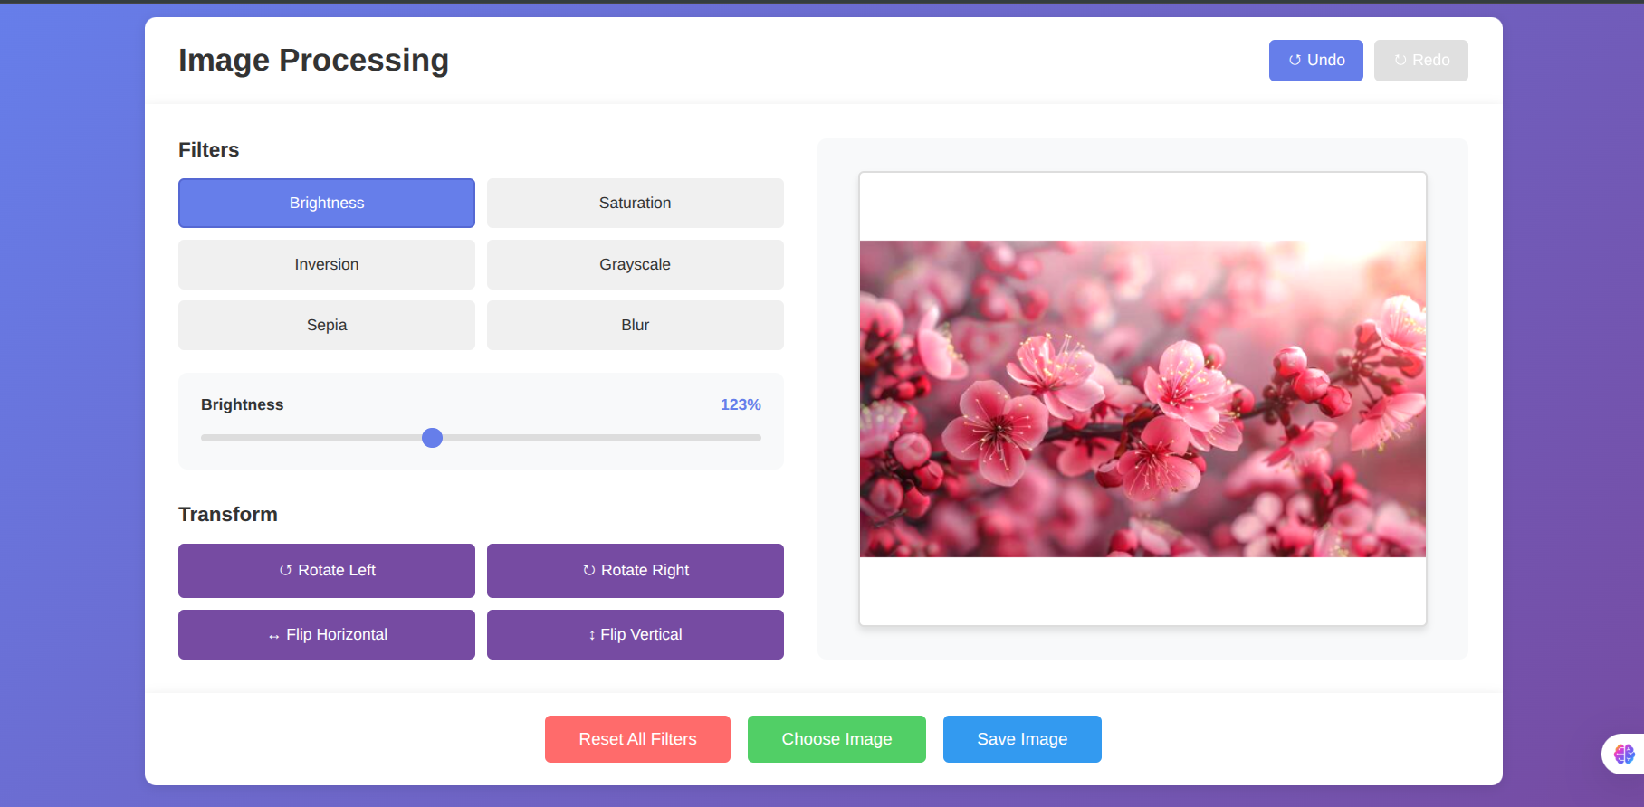

Self Made

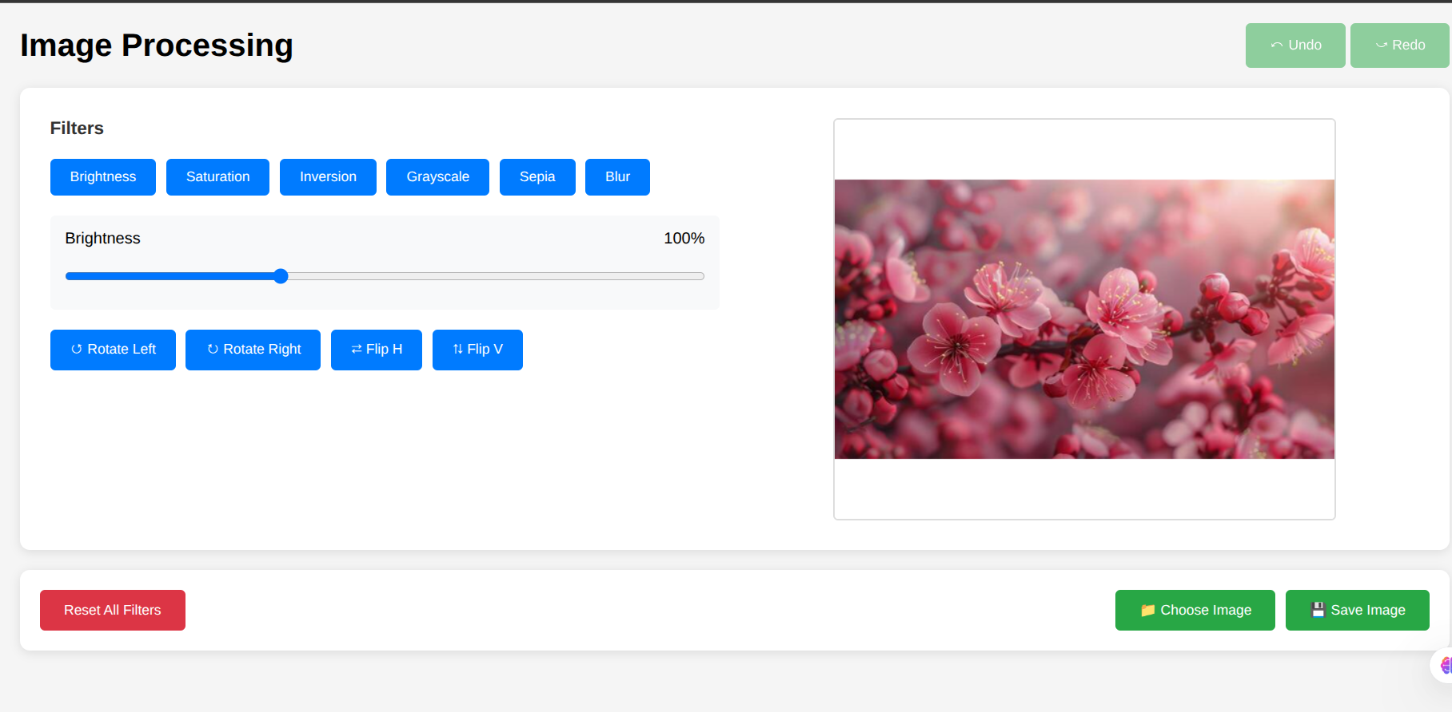

After a proper comparison including my previous tasks I concluded the main thing is prompt engineering. This prompt is extremely finely crafted ( made with Claude ). Each and every detail is mentioned in it with no ambiguity thats why whole website that took me 3 days to make was made within 5 minutes. Well it is said prompt engineering is way more important and can only be optimized it you know what you want.

Prompt given to AI:

Complete Prompt: Build a Canvas-Based Image Editor
Create a complete, functional image editor web application with the following specifications:

Core Requirements

1. Technology Stack
- Pure HTML, CSS, and JavaScript (no frameworks)
- Canvas-based rendering (no CSS transforms for image manipulation)
- Fixed canvas size: 500x400 pixels

2. Image Editing Features

Filters (with slider controls):
- Brightness: 0-200% (default: 100%)
- Saturation: 0-200% (default: 100%)
- Inversion: 0-100% (default: 0%)
- Grayscale: 0-100% (default: 0%)
- Sepia: 0-100% (default: 0%)
- Blur: 0-10px (displayed as 0-100 on slider, default: 0)

Transform Operations:
- Rotate Left: -90° rotation
- Rotate Right: +90° rotation
- Flip Horizontal: Mirror horizontally
- Flip Vertical: Mirror vertically

3. User Interface Components

Header Section:
- Title: "Image Processing" or similar
- Undo button (↺ icon)
- Redo button (↻ icon)

Main Container:
Left Panel - Filters Area:
- 6 filter mode buttons (Brightness, Saturation, Inversion, Grayscale, Sepia, Blur)
- Active filter should be visually highlighted
- Slider with current filter name and value display
- 4 transform buttons arranged in a grid (Rotate Left, Rotate Right, Flip H, Flip V)
Right Panel - Canvas Area:
- Canvas element (500x400px)
- Should display the edited image

Bottom Section:
- Reset All Filters button
- Choose Image button (file upload)
- Save Image button (download)

4. Technical Implementation Details

Canvas Rendering System:
CRITICAL: Use a pure canvas-based approach, NOT CSS transforms

1. Fixed canvas dimensions: Always 500x400px
2. Store original image separately
3. All rendering happens in a single drawImage() function
4. Apply all effects via canvas context, not CSS

Image Fitting Logic:
When loading an image:
1. Calculate rotated bounding box based on current rotation
2. Scale image to fit within 500x400 while maintaining aspect ratio
3. Center the image in the canvas (letterbox/pillarbox if needed)
4. Ensure rotated images always fit within canvas bounds

Formula for rotated bounding box:
rotatedWidth = |img.width × cos(θ)| + |img.height × sin(θ)|
rotatedHeight = |img.width × sin(θ)| + |img.height × cos(θ)|

Scale = min(CANVAS_WIDTH / rotatedWidth, CANVAS_HEIGHT / rotatedHeight)

Rendering Pipeline:
function drawImage() {
1. Clear canvas
2. Calculate layout based on rotation
3. Save context state
4. Apply filters via ctx.filter
5. Translate to canvas center
6. Rotate via ctx.rotate()
7. Scale for flip via ctx.scale()
8. Draw image centered at origin
9. Restore context state
}

Filter Application:
// Build filter string for canvas context
ctx.filter = `
brightness(${brightness}%)
saturate(${saturation}%)
invert(${inversion}%)
grayscale(${grayscale}%)
sepia(${sepia}%)
blur(${blur}px)
`;

State Management:
class ImageData {
constructor() {
this.inversion = 0;
this.brightness = 100;
this.saturation = 100;
this.grayscale = 0;
this.sepia = 0;
this.blur = 0;
this.rotate = 0;
this.fliph = 1; // 1 or -1
this.flipv = 1; // 1 or -1
}
}

5. Functionality Requirements

Filter Mode Switching:
- Clicking a filter button should:
  - Update the slider to show that filter's current value
  - Update the filter name display
  - Highlight the active filter button
  - Set appropriate slider min/max values

Slider Interaction:
- Real-time preview as slider moves
- Debounced history push (300ms after slider stops)
- Update value display dynamically

Transform Operations:
- Apply rotation/flip to internal state
- Call drawImage() to re-render
- Push to history immediately

Undo/Redo System:
- Store up to 20 states in history
- Track current position in history
- Disable undo button when at first state
- Disable redo button when at last state
- When new action occurs, truncate future history

Image Loading:
- File input dialog when "Choose Image" is clicked
- Reset all filters to default
- Store new image
- Call drawImage() to render
- Push initial state to history

Reset Functionality:
- Reset all filters to defaults (brightness/saturation: 100, others: 0)
- Reset rotation to 0°
- Reset flips to 1
- Redraw image
- Push to history

Save Functionality:
// SIMPLE - canvas already contains final result!
function saveImage() {
const link = document.createElement('a');
link.download = 'edited-image.png';
link.href = canvas.toDataURL('image/png');
link.click();
}

6. Code Structure
project/
├── index.html # Structure
├── style.css # Styling
└── script.js # Logic

JavaScript Organization:
// 1. Global variables and constants
const canvas, ctx, image_data, etc.

// 2. Image fitting calculations
function calculateImageLayout(img, rotation) { ... }

// 3. Core rendering
function drawImage() { ... }

// 4. Mode switching functions
function onChangeModeToBrightness() { ... }
function onChangeModeToSaturation() { ... }
// ... etc

// 5. Transform functions
function rotateLeft() { ... }
function rotateRight() { ... }
function flipHorizontal() { ... }
function flipVertical() { ... }

// 6. Filter application
function onInputSlider() { ... }

// 7. Button functions
function resetImage() { ... }
function chooseImageFtn() { ... }
function saveImage() { ... }

// 8. History management
function pushToHistory() { ... }
function undo() { ... }
function redo() { ... }
function updateUndoRedoButtons() { ... }
function updateUIFromCurrentState() { ... }

// 9. Event listeners
// Attach all event handlers

// 10. Initialize
// Load default image, set up initial state

7. Important Implementation Notes

✅ DO:
- Use canvas.getContext('2d') for all rendering
- Apply filters via ctx.filter property
- Apply rotation via ctx.rotate()
- Apply flip via ctx.scale()
- Keep canvas size fixed at 500x400
- Calculate image scale based on rotation
- Center image in canvas
- Store original image separately
- Redraw entire canvas on any change
- Use debouncing for slider history

❌ DON'T:
- Don't use CSS transforms (canvas.style.transform)
- Don't use CSS filters (canvas.style.filter)
- Don't resize canvas dynamically
- Don't manipulate pixels manually in save function
- Don't let rotated images overflow canvas
- Don't apply transforms without redrawing

8. Default Behavior

Initial Load:
// Load a test image (or show placeholder)
img.src = 'test_pic.jpeg';

// Initial state
brightness: 100%
saturation: 100%
all other filters: 0
rotation: 0°
flips: normal (1, 1)

// Active mode: Brightness
// History: [initial state]

Slider Max Values:
// Calculate based on roll number
const rollNumber = 579; // Example
const isEven = rollNumber % 2 === 0;
const maxStep = isEven ? 2 : 3;

// For Brightness and Saturation
filter_slider.max = maxStep * 100; // 200 or 300

// For all other filters
filter_slider.max = 100;

9. User Experience Details

Visual Feedback:
- Active filter button has distinct styling
- Slider value updates in real-time
- Undo/redo buttons disable when unavailable
- Smooth transitions on UI elements

Edge Cases to Handle:
- Loading very wide images → Scale to fit width
- Loading very tall images → Scale to fit height
- Rotating square images → Calculate new bounding box
- Multiple rapid filter changes → Debounce history
- Reaching history limits → Shift oldest entry
- Loading new image → Reset everything

10. Testing Checklist
Create an editor that can:
- ✅ Load different aspect ratio images
- ✅ Apply all 6 filters independently
- ✅ Combine multiple filters
- ✅ Rotate images at 90° increments
- ✅ Flip images horizontally and vertically
- ✅ Combine rotation + flip + filters
- ✅ Undo/redo all operations (20 steps)
- ✅ Reset all filters at once
- ✅ Save edited image as PNG
- ✅ Handle images that overflow when rotated
- ✅ Maintain aspect ratio always
- ✅ Center images with letterboxing

Example Code Snippets

HTML Structure:
<!DOCTYPE html>
<html lang="en">
<head>
<meta charset="UTF-8">
<title>Image Editor</title>
<link rel="stylesheet" href="style.css">
</head>
<body>
<main>
<div class="heading">
<h1>Image Processing</h1>
<div class="history">
<button id="undo">⤺ Undo</button>
<button id="redo">⤻ Redo</button>
</div>
</div>

<div class="container">
<div class="filters-area">
<h4>Filters</h4>
<div class="options">
<div class="button" onclick="onChangeModeToBrightness()">Brightness</div>
<!-- More filter buttons -->
</div>

<div class="slider-container">
<div class="slider-header">
<span id="filter-name">Brightness</span>
<span id="filter-value">100%</span>
</div>
<input type="range" id="filter-slider" min="0" max="200" value="100">
</div>

<div class="rotate-flip">
<div class="button" id="rotate-left">↺ Rotate Left</div>
<!-- More transform buttons -->
</div>
</div>

<div class="canvas-area">
<canvas id="image-canvas" width="500" height="400"></canvas>
</div>
</div>

<div class="buttons">
<button id="reset">Reset All Filters</button>
<button id="choose-image">Choose Image</button>
<button id="save-image">Save Image</button>
</div>
</main>
</body>
<script src="script.js"></script>
</html>

CSS (Basic Styling):
* {
margin: 0;
padding: 0;
box-sizing: border-box;
font-family: Arial, sans-serif;
}

body {
padding: 20px;
background: #f5f5f5;
}

.container {
display: flex;
gap: 30px;
background: white;
padding: 30px;
border-radius: 10px;
}

.filters-area {
flex: 1;
}

.canvas-area {
flex: 1;
display: flex;
justify-content: center;
align-items: center;
}

canvas {
border: 2px solid #ddd;
border-radius: 5px;
}

.options {
display: flex;
flex-wrap: wrap;
gap: 10px;
}

.button {
padding: 10px 20px;
background: #007bff;
color: white;
border-radius: 5px;
cursor: pointer;
}

button {
padding: 12px 24px;
background: #28a745;
color: white;
border: none;
border-radius: 5px;
cursor: pointer;
}

JavaScript Core Logic:
const canvas = document.getElementById('image-canvas');
const ctx = canvas.getContext('2d');

// Fixed canvas size
const CANVAS_WIDTH = 500;
const CANVAS_HEIGHT = 400;
canvas.width = CANVAS_WIDTH;
canvas.height = CANVAS_HEIGHT;

// Image state
class ImageData {
constructor() {
this.brightness = 100;
this.saturation = 100;
this.inversion = 0;
this.grayscale = 0;
this.sepia = 0;
this.blur = 0;
this.rotate = 0;
this.fliph = 1;
this.flipv = 1;
}
}

const image_data = new ImageData();
let originalImage = new Image();
let currentMode = "Brightness";

// Calculate layout to fit image in canvas
function calculateImageLayout(img, rotation) {
const rad = (rotation % 360) * Math.PI / 180;
const absRad = Math.abs(rad);

// Rotated bounding box
const rotatedWidth = Math.abs(img.width * Math.cos(absRad)) +
Math.abs(img.height * Math.sin(absRad));
const rotatedHeight = Math.abs(img.width * Math.sin(absRad)) +
Math.abs(img.height * Math.cos(absRad));

// Scale to fit
const scaleX = CANVAS_WIDTH / rotatedWidth;
const scaleY = CANVAS_HEIGHT / rotatedHeight;
const scale = Math.min(scaleX, scaleY);

return {
scale: scale,
displayWidth: img.width * scale,
displayHeight: img.height * scale,
centerX: CANVAS_WIDTH / 2,
centerY: CANVAS_HEIGHT / 2
};
}

// Main rendering function
function drawImage() {
if (!originalImage.complete) return;

// Clear
ctx.clearRect(0, 0, CANVAS_WIDTH, CANVAS_HEIGHT);

// Calculate layout
const layout = calculateImageLayout(originalImage, image_data.rotate);

// Save state
ctx.save();

// Apply filters
ctx.filter = `
brightness(${image_data.brightness}%)
saturate(${image_data.saturation}%)
invert(${image_data.inversion}%)
grayscale(${image_data.grayscale}%)
sepia(${image_data.sepia}%)
blur(${(image_data.blur / 100) * 10}px)
`.trim();

// Transform
ctx.translate(layout.centerX, layout.centerY);
ctx.rotate(image_data.rotate * Math.PI / 180);
ctx.scale(image_data.fliph, image_data.flipv);

// Draw
ctx.drawImage(
originalImage,
-layout.displayWidth / 2,
-layout.displayHeight / 2,
layout.displayWidth,
layout.displayHeight
);

// Restore
ctx.restore();
}

// Event handlers
function onChangeModeToBrightness() {
currentMode = 'Brightness';
// Update UI
}

function rotateRight() {
image_data.rotate += 90;
drawImage();
pushToHistory();
}

function saveImage() {
const link = document.createElement('a');
link.download = 'edited-image.png';
link.href = canvas.toDataURL('image/png');
link.click();
}

// Initialize
originalImage.onload = function() {
drawImage();
pushToHistory();
};
originalImage.src = 'test_pic.jpeg';

Deliverables
Please provide three files:
- index.html - Complete HTML structure
- style.css - Complete styling (basic, functional design)
- script.js - Complete JavaScript implementation
The application should be:
- ✅ Fully functional with all features working
- ✅ Using canvas-based rendering (not CSS transforms)
- ✅ Handling rotation properly (images always fit in canvas)
- ✅ Maintaining aspect ratios
- ✅ Supporting undo/redo (20 states)
- ✅ Able to save edited images
- ✅ Clean, well-commented code
Focus on functionality and correctness. The UI should be clean and simple (not fancy), with clear labels and intuitive controls.

